CMR TECHNICAL CAMPUS

UGC AUTONOMOUS
Accredited by NBA & NAAC with ‘A’ Grade Approved by AICTE, New Delhi and JNTU Hyderabad

Department of Computer Science and Engineering
APPLICATION OF RFID TECHNOLOGY AND THE MAXIMUM SPANNING TREE ALGORITHM FOR SOLVING VEHICLE EMISSIONS IN CITIES ON INTERNET OF THINGS


This project presents an innovative approach to reducing vehicle emissions in urban areas by integrating Radio Frequency Identification (RFID) technology with the Maximum Spanning Tree (MST) algorithm within an Internet of Things (IoT) framework. Vehicles equipped with RFID tags transmit their location and emission data to strategically deployed IoT sensors throughout the city, enabling continuous and automated data collection. The MST algorithm organizes this interconnected system into an optimized network topology that maximizes coverage and ensures efficient data routing with minimal redundancy. Through real-time monitoring and analysis, the system can identify emission hotspots, support intelligent traffic rerouting, and provide data-driven policy recommendations.
 | 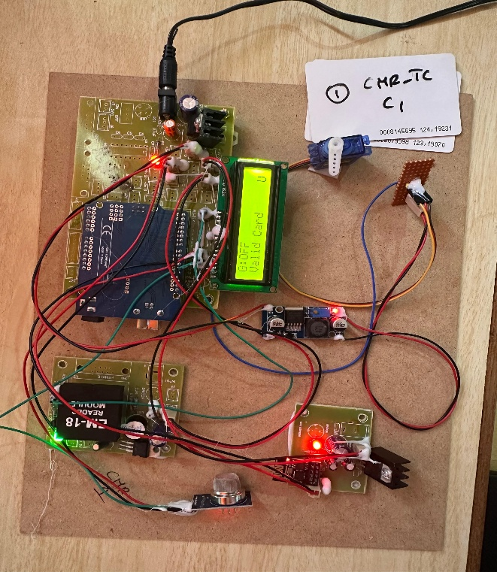
Urbanization and the rapid increase in vehicle ownership have significantly contributed to rising air pollution levels in modern cities, with vehicular emissions posing serious environmental and public health challenges. Traditional traffic monitoring and emission control systems often lack real-time data collection and integrated management, making them insufficient for densely populated urban areas. The Internet of Things (IoT) enables interconnected sensors and devices to continuously monitor urban infrastructure and support intelligent decision-making. Within this framework, Radio Frequency Identification (RFID) technology facilitates automatic vehicle identification and seamless data collection, as RFID tags embedded in vehicles can store registration and emission-related information for dynamic tracking. However, processing large volumes of vehicular data requires efficient optimization methods. The Maximum Spanning Tree (MST) algorithm enhances network efficiency by prioritizing high-weight links representing emission intensity or traffic density.
  - Periodic manual inspections.  - Engine Upgrades  - Better Fuel (Quality)  - Inconsistent Enforcement  - Lack of Automation and Optimization | Batch-1:  Abdul Wasil Ahmed 247R1A0566  M. Sindhu 247R1A05A1  G. Rishi 247R1A0584
FACULTY SUPERVISOR
Dr.K.Maheshwari, Assistant Professor.
This project proposes a smart solution to reduce vehicle emissions by combining Radio Frequency Identification (RFID) technology and the Maximum Spanning Tree (MST) algorithm within an Internet of Things (IoT) framework. RFID-equipped vehicles send real-time location and emission data to IoT sensors across the city. The MST algorithm optimizes the network for efficient data routing and coverage. This system enables real-time monitoring, identifies pollution hotspots, and supports traffic rerouting, helping reduce urban air pollution.

